Answer the following questions:

1. (**POGIL**) Insert a screenshot of your Logicly diagram for the Exclusive-OR circuit below.

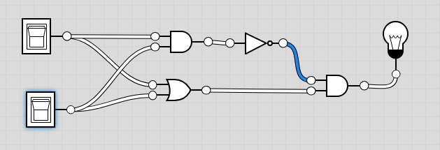

2. (**POGIL**) Consider these three things: The *OR gate* (i.e., the physical circuit), the *Boolean OR function* (as defined by its truth table), and the *OR symbol*. How would arrange them from **most abstract to least abstract**? And what criterion would you use to determine their order?

**Answer**

|  |
| --- |
| **OR Symbol, Boolean OR function, physical circuit** |

3. Consider these three things: A binary digit (e.g., 1 or 0), the flip-flop circuit diagram (), and the flip-flop circuit (i.e., the physical circuit). How would you arrange them from **most abstract to least abstract** and what criterion would you use to determine their order?

**Answer**

|  |
| --- |
| **binary digit, flip flop circuit diagram, Flip flop circuit.** |